**LIT ASSIGNMENT**

**Day - 12**

**Emp Id : 46255197**

**Name : LUV MALHOTRA.**

**Q1: Adobe form to display flight booking details**

**Table type:**

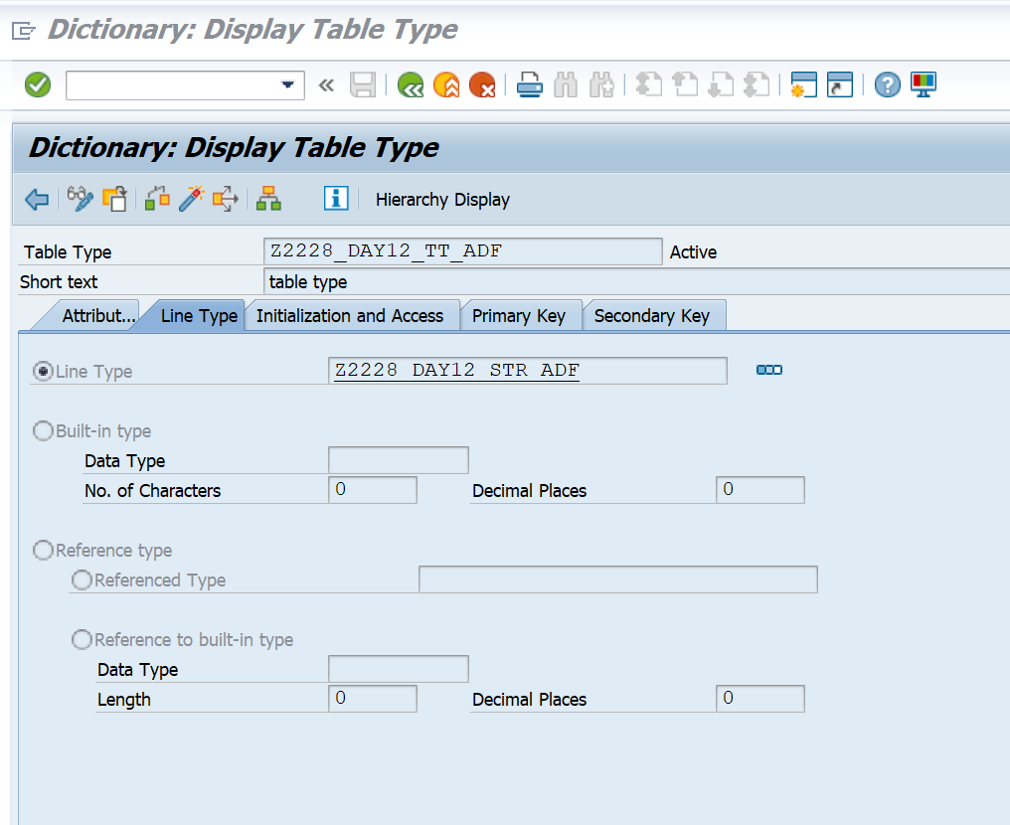

**Structure:**

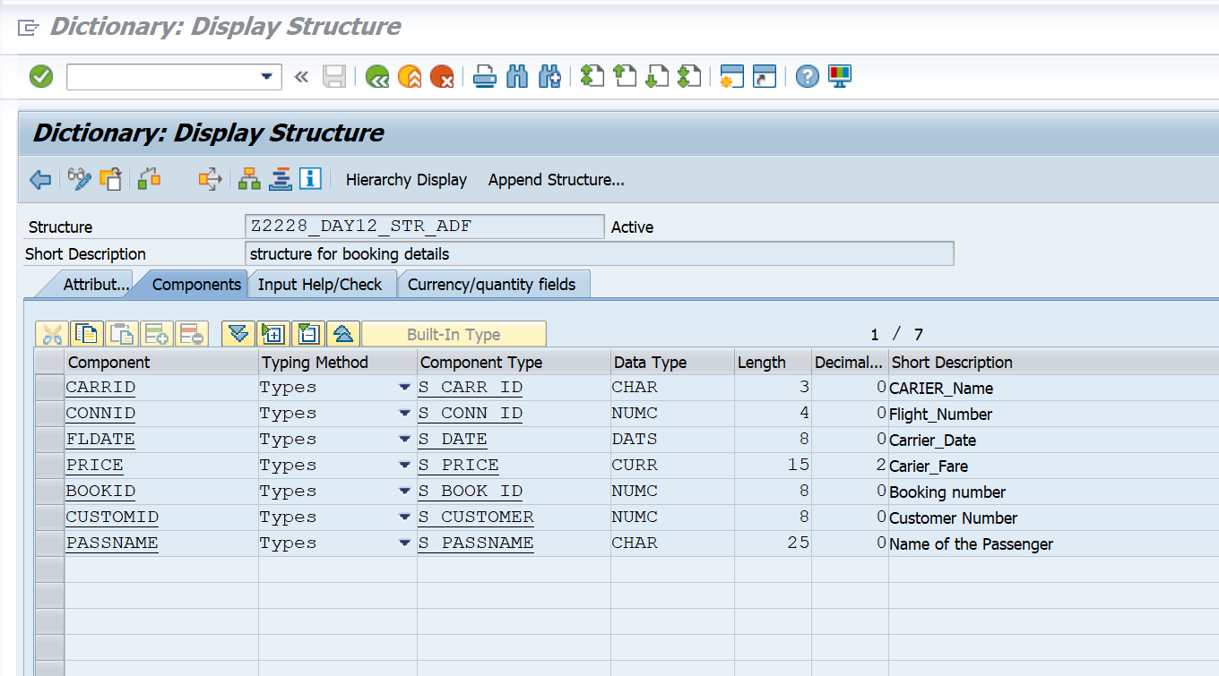

**Interface:  Tcode -SFP**

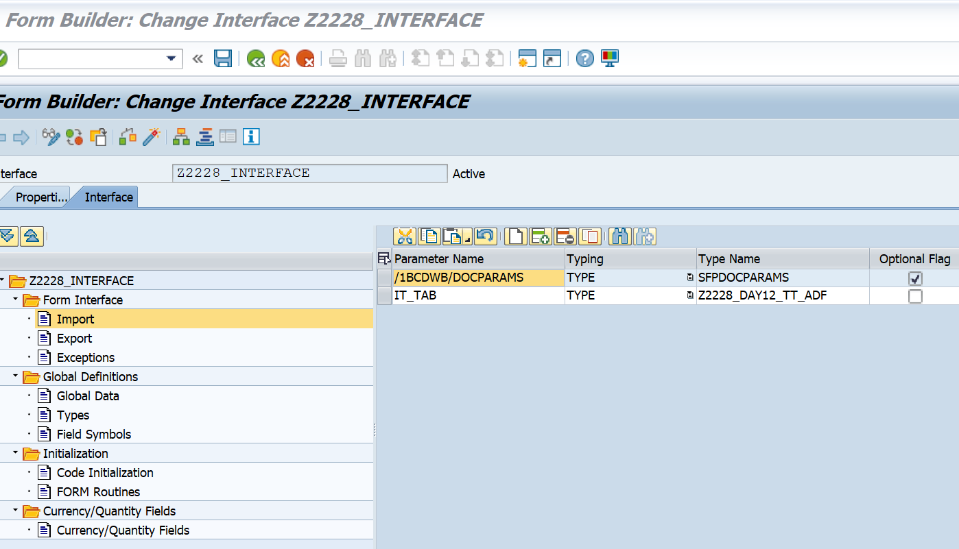

**Context:**

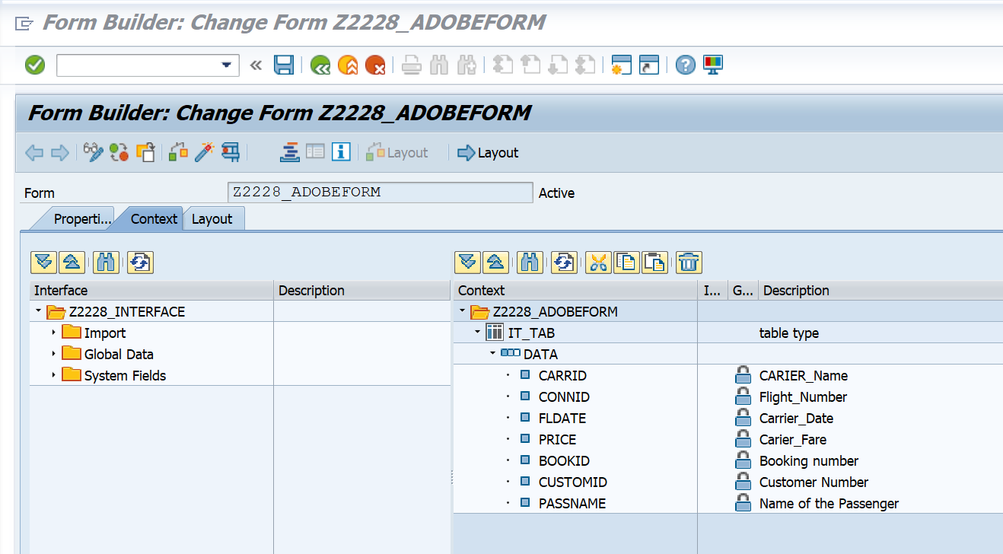

**Form Layout:**

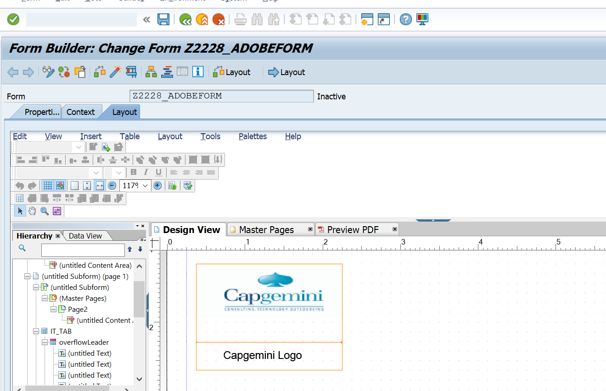

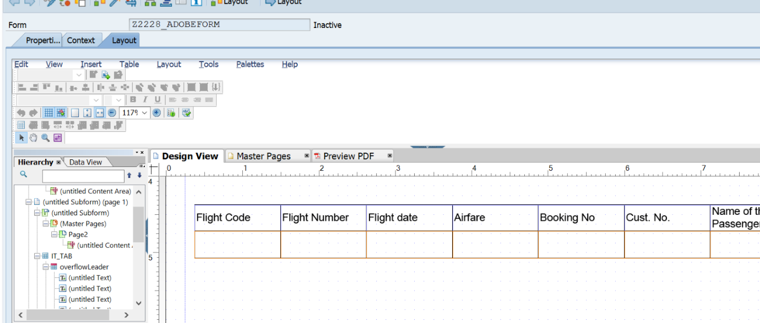

**Program:**

REPORT Z2228_ADOBEFORMS.    
    
tables : sflight ,spfli, sbook.    
    
data it_tab type standard table of Z2228_DAY12_STR_ADF.    
    
DATA  wa_oparams type sfpoutputparams.    
    
    
SELECT-OPTIONS : s_carrid FOR spfli-carrid.    
 SELECT spfli~carrid    
       spfli~connid    
       sflight~fldate    
       sflight~price    
       sbook~bookid    
       sbook~customid    
       sbook~passname    
FROM spfli INNER JOIN sflight    
ON spfli~carrid EQ sflight~carrid    
INNER JOIN sbook    
ON spfli~carrid EQ sbook~carrid    
UP TO 10 ROWS       *"selecting fields from SPFLI , SFLIGHT and SBOOK*    
INTO TABLE it_tab                                                    *"into internal table*    
WHERE spfli~carrid IN s_carrid.    
    
CALL FUNCTION 'FP_JOB_OPEN'    
  CHANGING    
    ie_outputparams       = wa_oparams    
*\* EXCEPTIONS*    
*\*   CANCEL                = 1*    
*\*   USAGE_ERROR           = 2*    
*\*   SYSTEM_ERROR          = 3*    
*\*   INTERNAL_ERROR        = 4*    
*\*   OTHERS                = 5*    
          .    
IF sy-subrc <> 0.    
*\* Implement suitable error handling here*    
ENDIF.    
    
CALL FUNCTION '/1BCDWB/SM00001200'    
  EXPORTING    
*\*   /1BCDWB/DOCPARAMS        =*    
    it_tab                   = it_tab    
*\* IMPORTING*    
*\*   /1BCDWB/FORMOUTPUT       =*    
*\* EXCEPTIONS*    
*\*   USAGE_ERROR              = 1*    
*\*   SYSTEM_ERROR             = 2*    
*\*   INTERNAL_ERROR           = 3*    
*\*   OTHERS                   = 4*    
          .    
IF sy-subrc <> 0.    
*\* Implement suitable error handling here*    
ENDIF.    
    
    
CALL FUNCTION 'FP_JOB_CLOSE'    
*\* IMPORTING*    
*\*   E_RESULT             =*    
*\* EXCEPTIONS*    
*\*   USAGE_ERROR          = 1*    
*\*   SYSTEM_ERROR         = 2*    
*\*   INTERNAL_ERROR       = 3*    
*\*   OTHERS               = 4*    
          .    
IF sy-subrc <> 0.    
*\* Implement suitable error handling here*    
ENDIF.

**Output:**



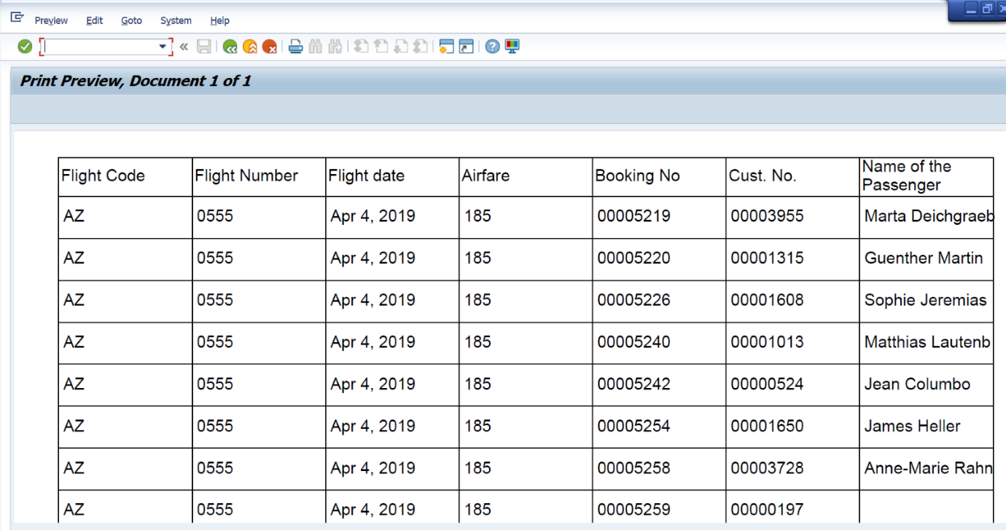

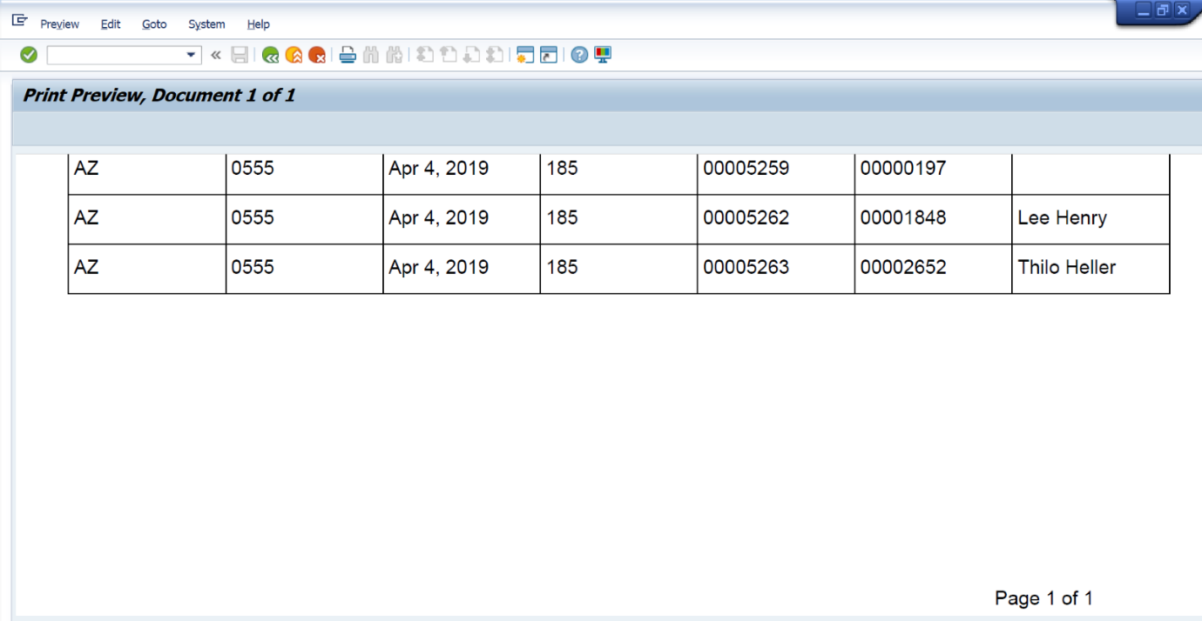

**Q2:  Java Script to display footer only last page**

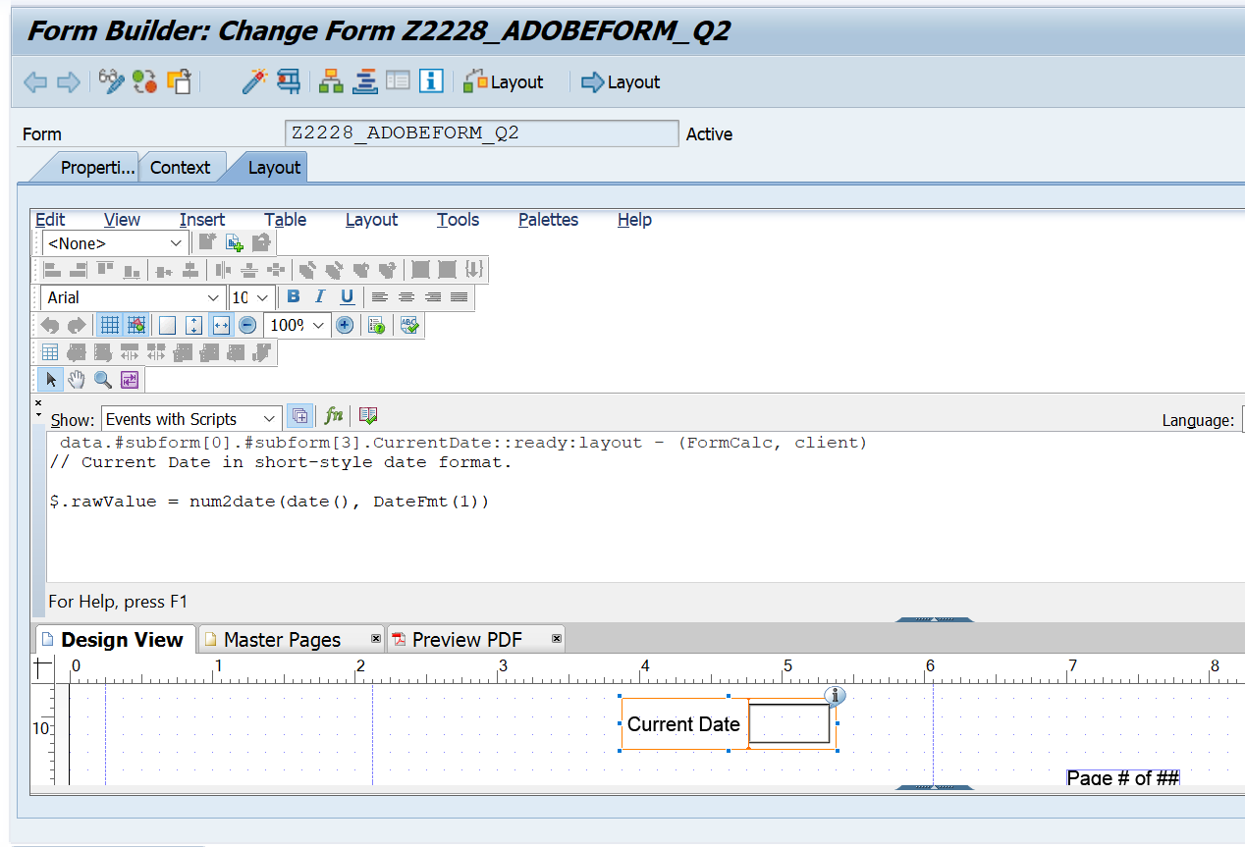

**Output:**



**Q4: Dynamic text in Adobe form**

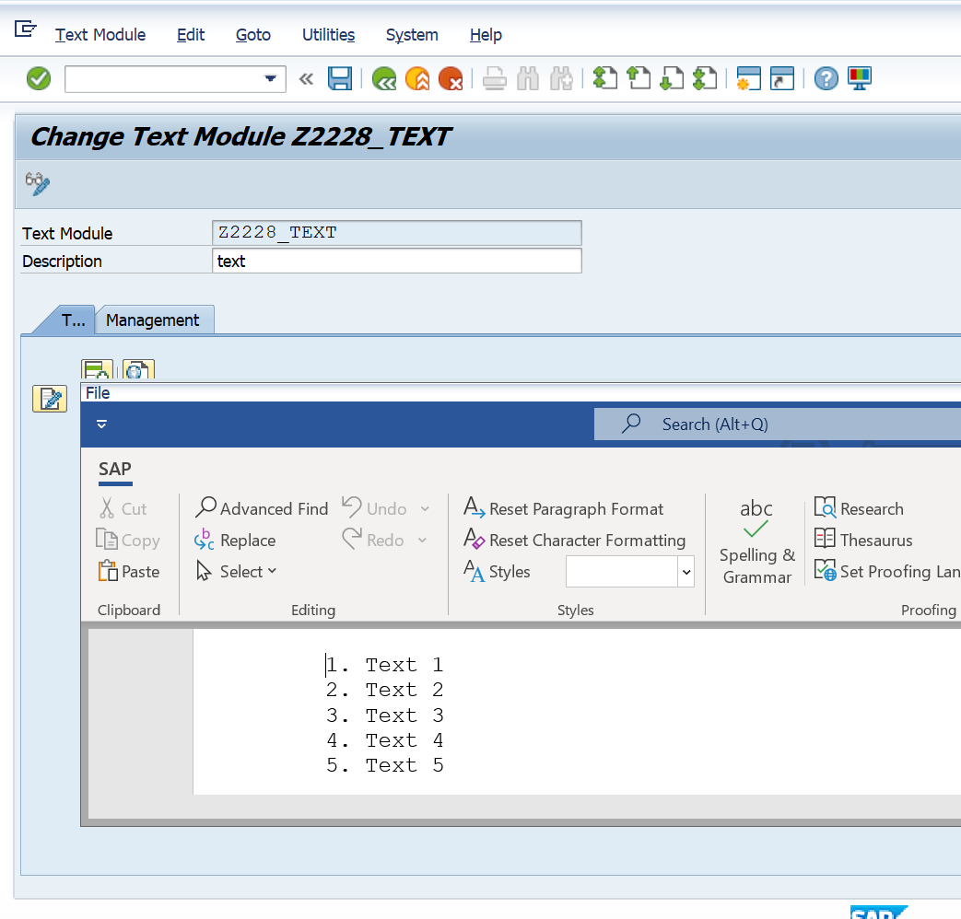

**Context:**

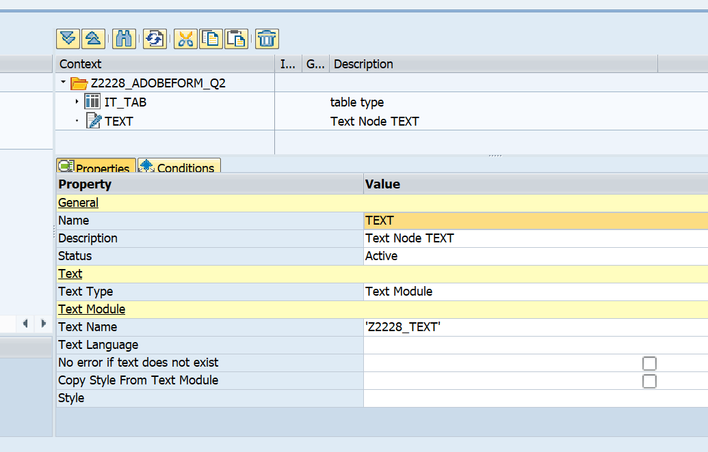

**Layout:**

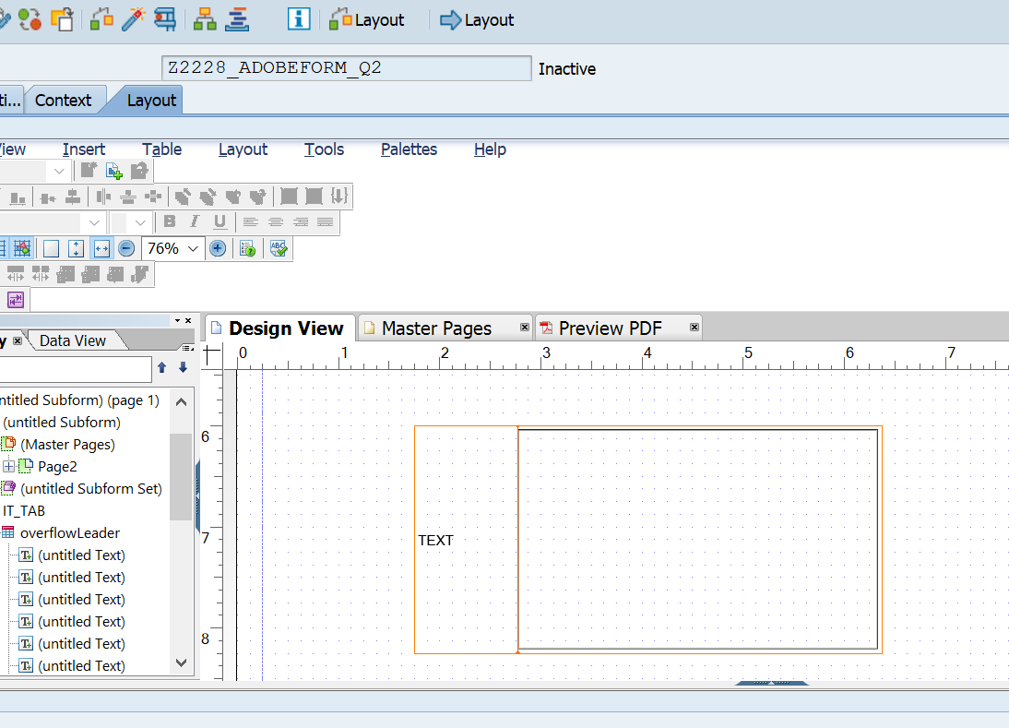

**Output:**

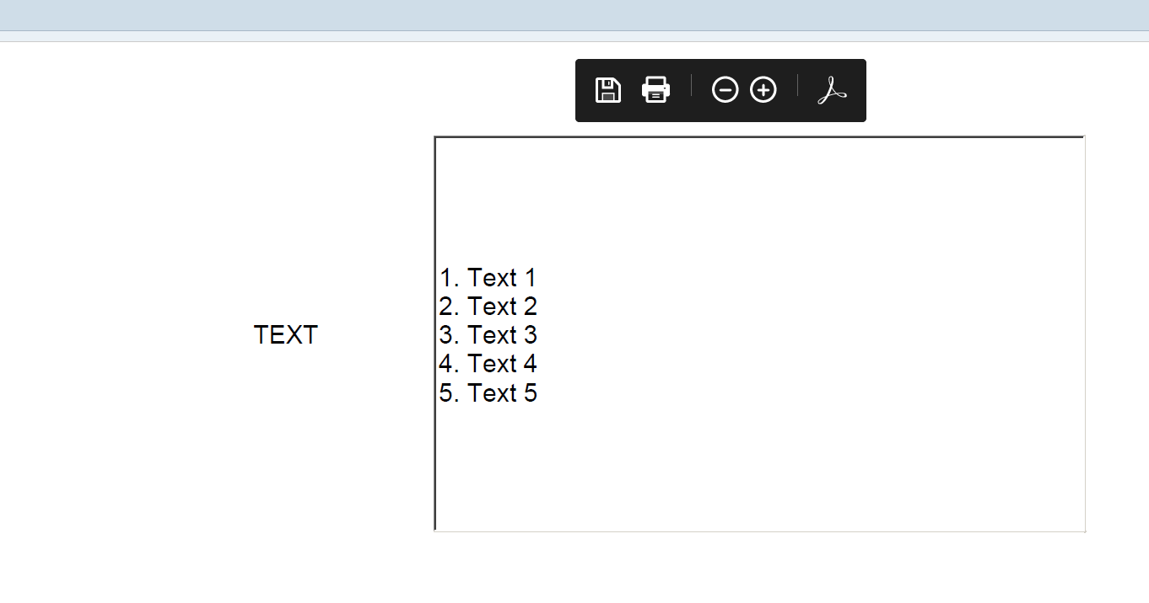

**Q5: Include test**

**Table type:**

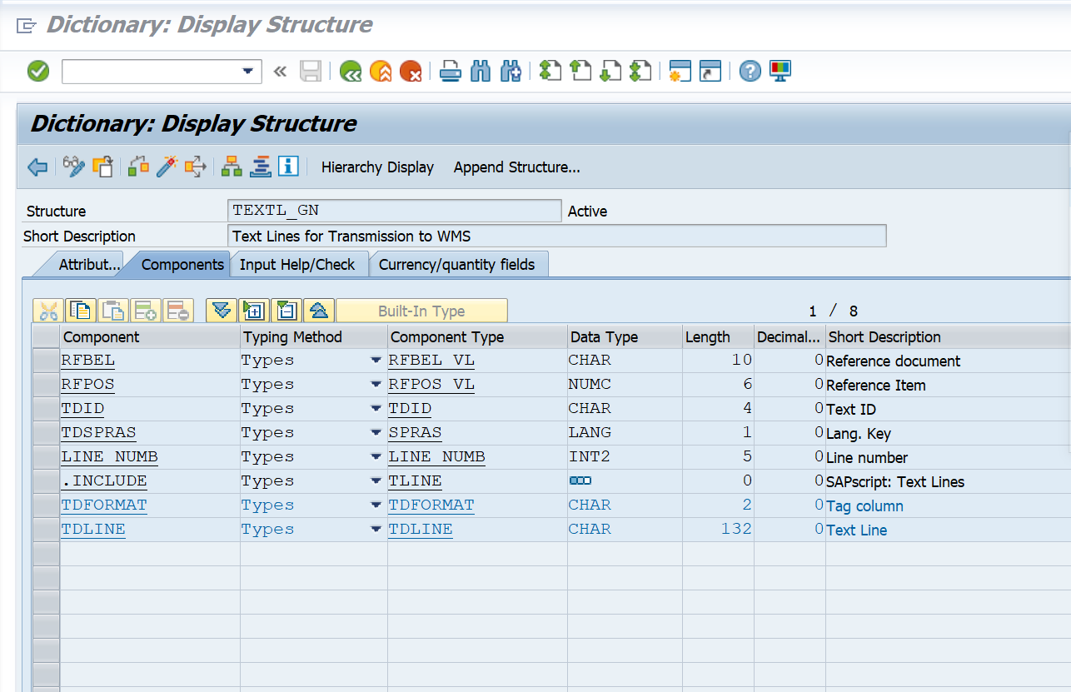

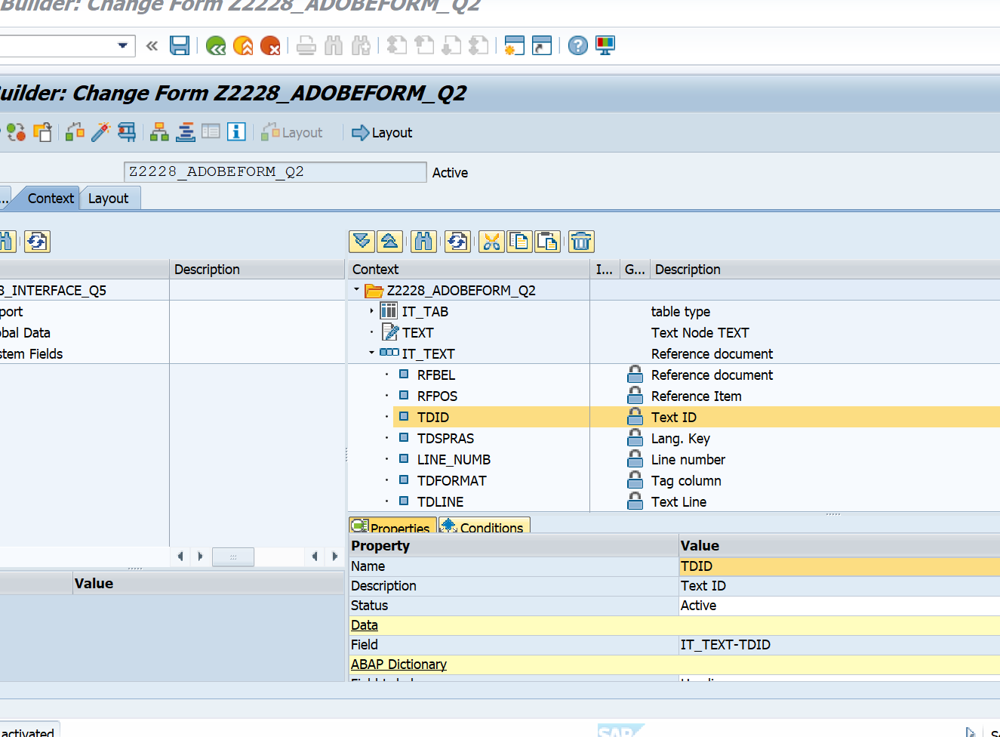

**Layout:**

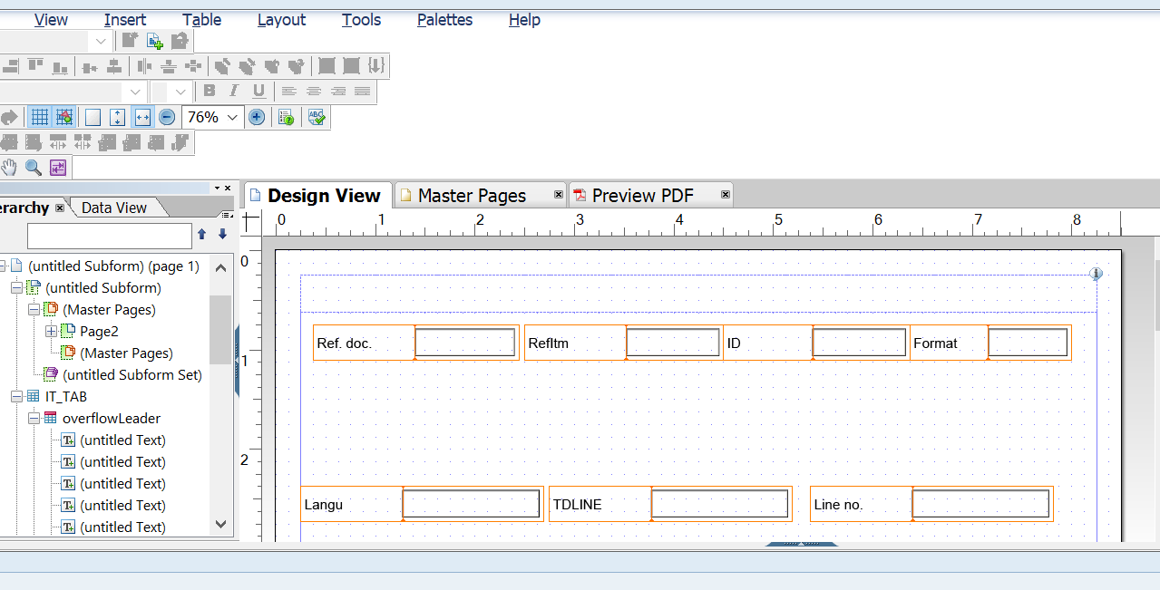

**Output:**

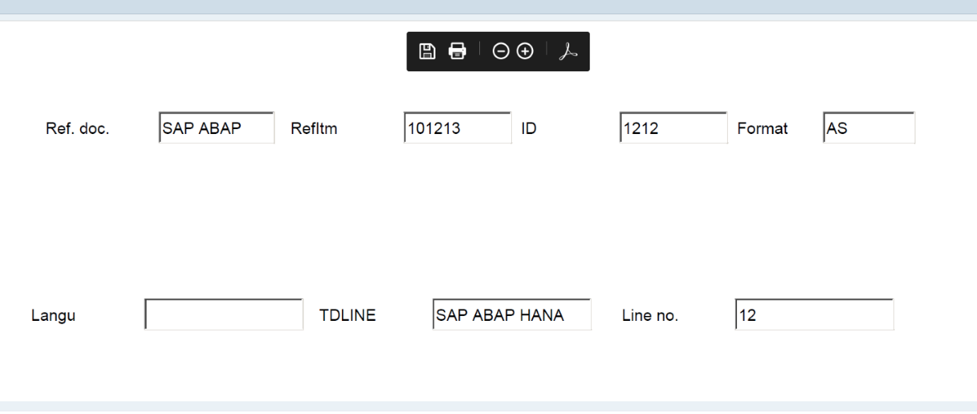

**Capgemini logo using SE78:**

**Form Interface:**

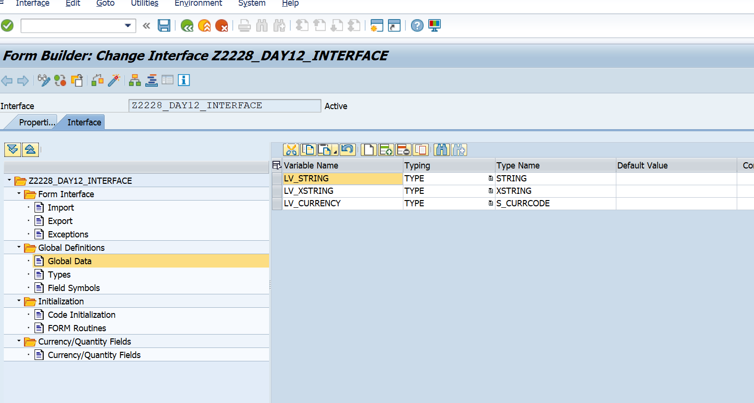

**Code Initialization:**

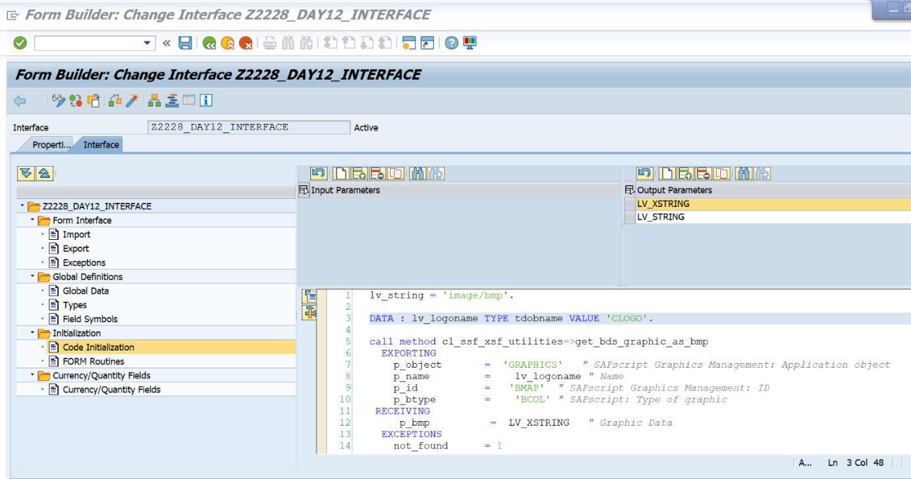

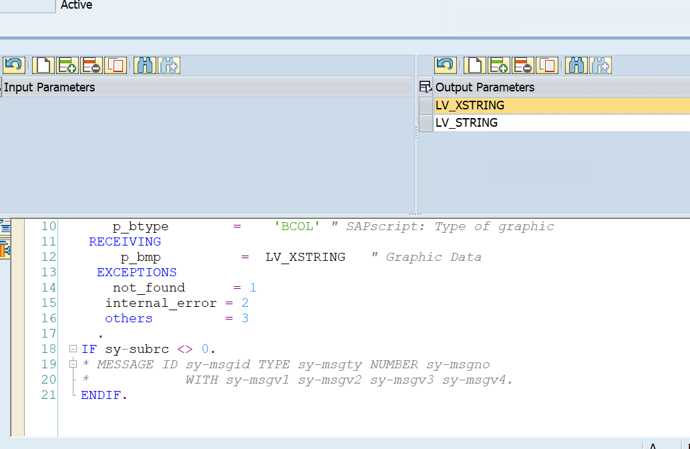

**Form Layout:**

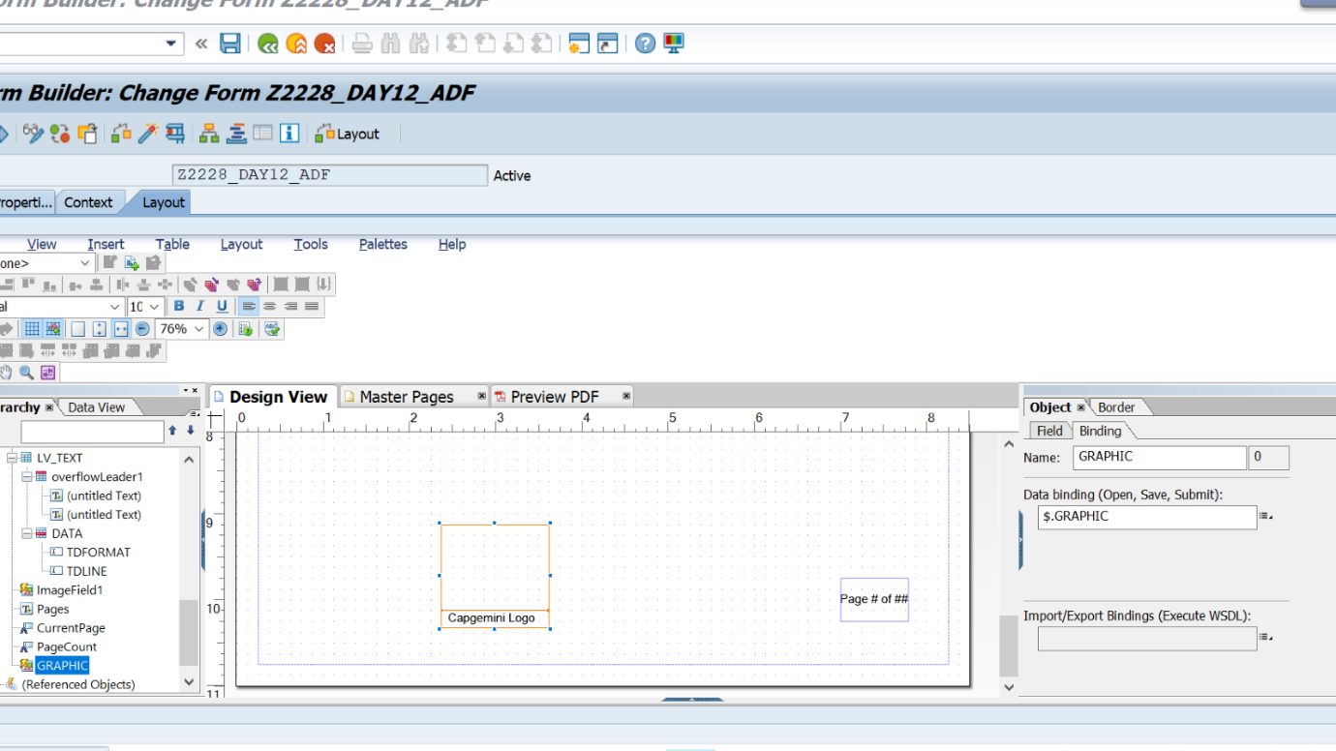

**Output:**

